NAME: __________________________ DATE DUE: ____________
TEACHER: ________________________
/31
Year 11 Term 1 – Chemistry
HOMEWORK SHEET No. 2 – Atomic Structure and Isotopes
/8 | 1. For each question below, construct a statement using the word(s) provided which correctly describes a feature of the periodic table. Each sentence should include an example, and be twenty words or less.  a) Atomic number: ___________________________________________________________________ ________________________________________________________________________________________  b) Electron shell: ___________________________________________________________________ ________________________________________________________________________________________  c) Metal/non-metal: ___________________________________________________________________ ________________________________________________________________________________________  d) 1st ionisation energy: ___________________________________________________________________ ________________________________________________________________________________________  e) atomic radi: ___________________________________________________________________ ________________________________________________________________________________________  f) valences: ___________________________________________________________________ ________________________________________________________________________________________  g) electronegativity: ___________________________________________________________________ ________________________________________________________________________________________  h) ionic radii: ___________________________________________________________________ ________________________________________________________________________________________
/16 | 2. What is the total number of valence electrons in an atom of xenon, Xe?  (A) 0 (B) 2 (C) 8 (D) 18  3. The elements calcium and strontium have similar chemical properties because they both have the same  (A) atomic number (B) mass number  (C) number of valence electrons (D) number of completely filled sublevels  4. On the Periodic Table of the Elements, all the elements within Group 16 have the same number of  (A) valence electrons (B) energy levels (C) protons (D) neutrons  5. An element with a partially filled d sublevel in the ground state is classified as  (A) a halogen (B) a transition metal (C) an alkali metal (D) an alkaline earth metal  6. Which of the following atoms has the largest atomic radius?  (A) Na (B) K (C) Mg (D) Ca  7. Which noble gas has the highest first ionization energy?  (A) radon (B) krypton (C) neon (D) helium  8. Which sequence of elements is arranged in order of decreasing atomic radii?  (A) Al, Si, P (B) Li, Na, K (C) Cl, Br, I (D) N, C, B  9. Which list of elements from Group 2 on the Periodic Table is arranged in order of increasing atomic radius?  (A) Be, Mg, Ca (B) Ca, Mg, Be (C) Ba, Ra, Sr (D) Sr, Ra, Ba  10. As each successive element in Group 15 of the Periodic Table is considered in order of increasing atomic number, the atomic radius  (A) decreases (B) increases (C) remains the same  11. The strength of an atom’s attraction for the electrons in another atom is referred to as  (A) electronegativity (B) ionization energy (C) bonding energy (D) energy of vaporisation  12. Which properties are most common in nonmetals?  (A) low ionization energy and low electronegativity  (B) low ionization energy and high electronegativity  (C) high ionization energy and low electronegativity  (D) high ionization energy and high electronegativity  13. Which Group 17 element has the least attraction for electrons?  (A) F (B) Cl (C) Br (D) I  14. Which element in Group 16 has the greatest tendency to gain electrons?  (A) Te (B) Se (C) S (D) O  15. The Group 17 element with the highest electronegativity is  (A) fluorine (B) chlorine (C) bromine (D) iodine  16. As the elements of Group 1 on the Periodic Table are considered in order of increasing atomic radius, the ionization energy of each successive element generally  (A) decreases (B) increases (C) remains the same  17. The amount of energy required to remove the outermost electron from a gaseous atom in the ground state is known as  (A) first ionization energy (B) activation energy (C) conductivity (D) electronegativity
/4 | 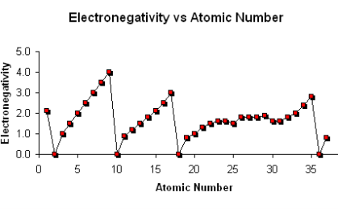  18. The chart below shows the relationship between electronegativity and atomic number. Describe the patterns you observe within this graph which relate to the structure of the periodic table.  _____________________________________________________ _____________________________________________________ _____________________________________________________ ________________________________________________________________________________________________________________________________________________________________________________
/3 | 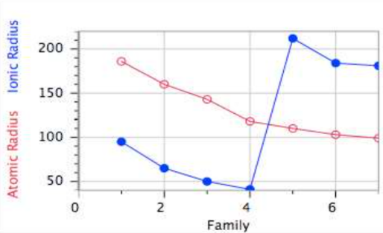  19. For elements in row three, determine the trend that exists between atomic radius and ionic radius. Explain the trend between the two lines.  _____________________________________________________ _____________________________________________________ _____________________________________________________ _____________________________________________________ ________________________________________________________________________________________  ________________________________________________________________________________________  _______________________________________________________________________________________

